**AD - 1 Use case Diagram**

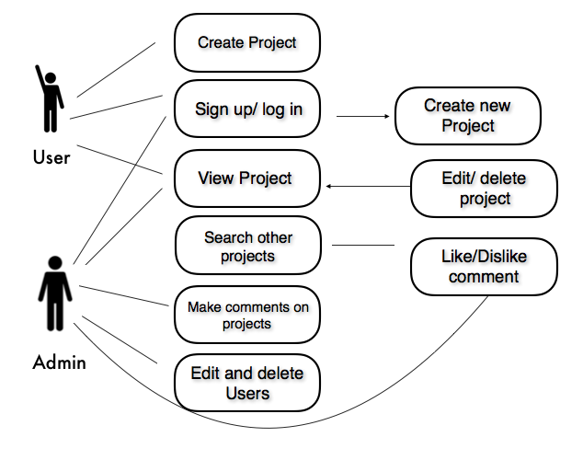

**AD - 2 Create a Class diagram using your Use case diagram.**

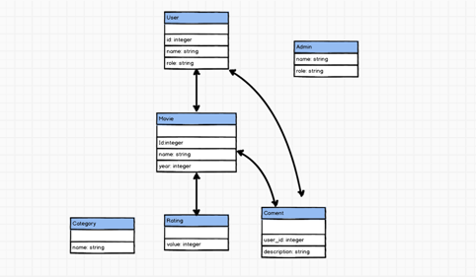

**AD - 3 Object diagram**

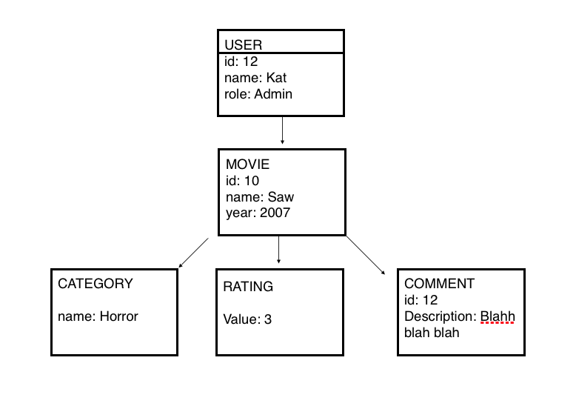

**AD - 4 Activity diagram**

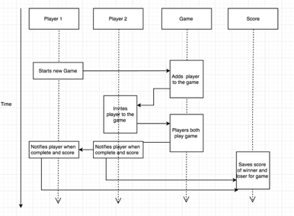

**AD - 5 Inheritance diagram**

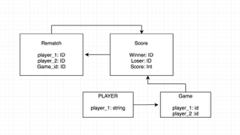

**AD - 6 Implementations Constraints**

|  |  |  |
| --- | --- | --- |
| **Constraints** | **Possible effect of constraint** | **Details** |
| **Hardware and software platforms** | **My Website can not be used from a phone or tablet since it is not fully responsive. That will have a negative impact to the amount of users that will be visiting the site because it can only be run from a desktop.** | **The course did not cover CSS in depth and time constraints did not allow me to do my own research so that i could be able to implement a fully responsive functionality to my website.** |
| **Performance requirements** | **User can only sort transactions by tag. This constraint of the website’s performance makes it really difficult to sort transactions in a chronological order which could lead to users being very confused when organizing a long list of transactions. Due to this less users will visit the website.** | **Time constraint was very limiting in regards to the implementation of this functionality.** |
| **Persistent storage and transactions** | **Database is run locally therefore issues with the stored data could be encountered which would lead to extra costs due to the recovering of such data.** | **Budget for the project did not cover the costs of renting an external server.** |
| **Budgets** | **There was no budget used in this project** | **Personal project for the course of codeclan.** |
| **Time** | **The lack of advanced functionality due to time constraints could make users to not feel drawn to use the website therefore a negative impact in the user uptake of the website.** | **The website is useful, however the implementation of more advanced functionalities will make it a much better app. My plan is to implement some of these in the future.** |

**Website design is not responsive. Only us**

**able on a desktop. This will hinder the amount of devices that can run the website as intended and ergo contract the user base due to users expecting the website to be used cross platform**

**Time constraints did not allow for a resign of the CSS to make it functional on devices other than a desktop.**

**The search bar requires you to enter the name perfectly (case sensitive), offering no suggestions if you get it close/wrong. This limits the usefulness of the search bar to the point where it's not usable by someone who doesn't know the data**

**Time constraints limited the ability to go and refactor and improve the search function however, it will be a quick fix. The app is also only in use by the owner of the record store meaning good knowledge of the data stored.**

**The database is not run externally therefore this could lead to issues with data corruption with undedicated machines taking care of storing the data. This could lead to having to recover data and therefore significantly increase costs instead of only minorly increasing costs by implementing an external database**

**Time was a limiting factor with this project as there was only 6 days to complete it. Advanced functionality suffered from this. The lack of functionality could cause a domino effect and the product will have less user uptake due to competing inventory management apps. More time would allow for more time for development therefore a better product and more profit**